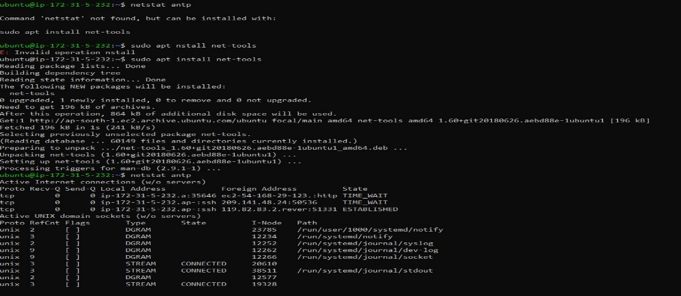

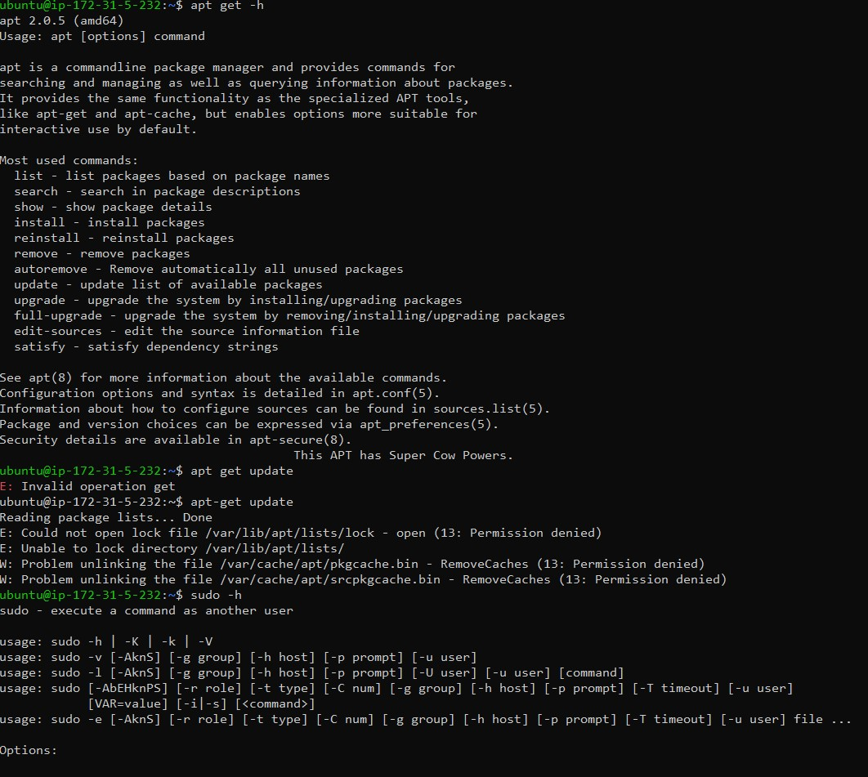

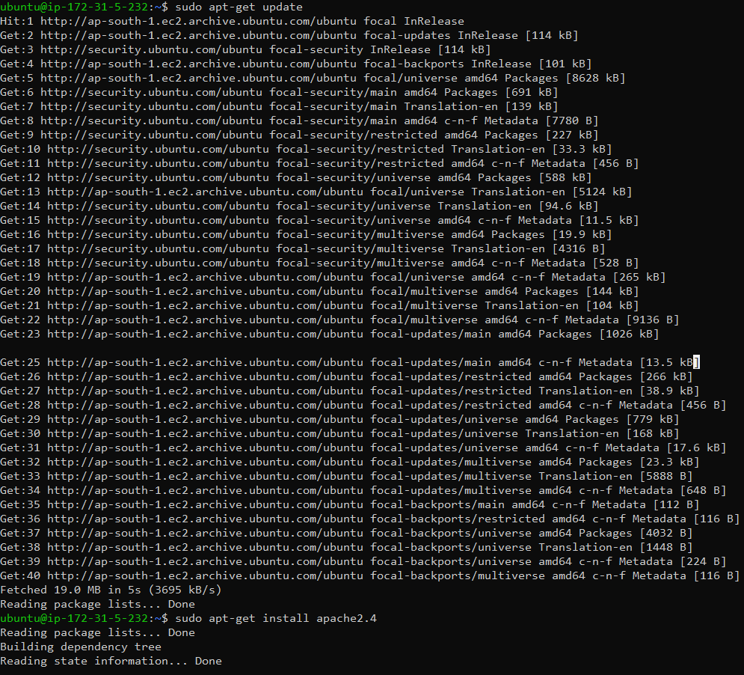

Go to this link:-

<https://linuxbeast.com/tutorials/aws/install-apache2-on-amazon-ec2-ubuntu-18-04/>

Installation & Process Link :-

https://www.techrepublic.com/article/how-to-use-the-apache-web-server-to-install-and-configure-a-website/

**Step 1. Installing Apache2 Web Server**

First, SSH remote into your EC2 instance using your great Linux terminal console and add the Apache2 system packages below, type command:

sudo add-apt-repository ppa:ondrej/apache2Copy

Then press Enter on the screen to continue.

Update the packages currently installed on the system, type command:

sudo apt updateCopy

Now install Apache2 Web Server, type command:

sudo apt-get install apache2 -yCopy

After installation completed, verify the Apache2 version.

sudo apache2ctl -v

The output looks like this:

Server version: Apache/2.4.41 (Ubuntu)

Server built:   2019-04-02T20:30:26Copy

## Step 2. ****Testing Apache2 Web Server****

After the installation process, the Apache2 service will runs automatically. To make sure the Apache2 is active (Running) online, type command:

sudo service apache2 statusCopy

The output looks like this:

We assume that Apache2 is already install and active. Next, You need to verify the default Apache2 landing page in the web browser if the Apache2 web server is working properly.

**Note**: Make sure HTTP Port 80 is publicly allowed from the incoming traffic in security group on your EC2 instance.

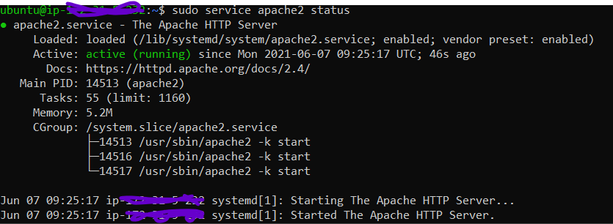

To get the public IP address on your server, type command:

curl http://169.254.169.254/latest/meta-data/public-ipv4Copy

The output looks like this:

52.XX.XX.XXCopy

Open your web browser and paste your public IP address.

http://52.XX.XX.XXCopy

The output looks like this:

Open your web browser and paste your public IP address.

http://52.XX.XX.XXCopy

The output looks like this:

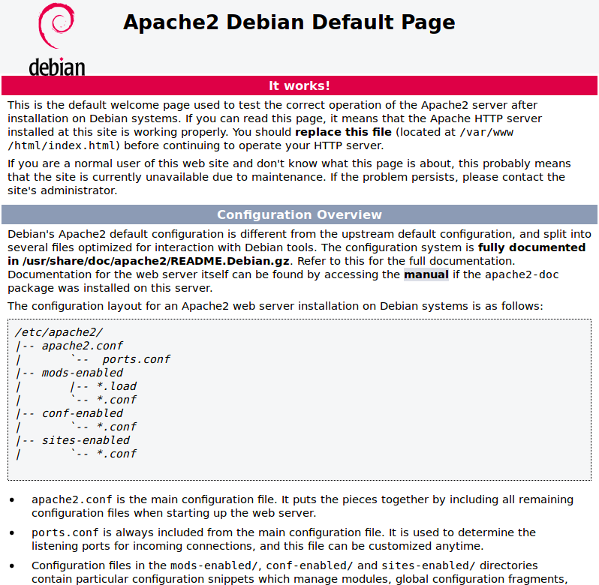

**Step 3. Apache2 Commands**

You can manage your Apache2 web server common commands:

# Start Apache service

sudo service apache2 start

# Stop Apache service

sudo service apache2 stop

# Restart Apache service

sudo service apache2 restart

# Reload Apache service without dropping connections

sudo service apache2 reload

# Enable Apache service on startup boot

sudo systemctl enable apache2

# Disable Apache service

sudo systemctl disable apache2

What is that page Apache is serving up? If you look in /var/www/html, you'll find the index.html file--let's change it.

Back at the terminal window, rename that index.html file with the command:

sudo mv /var/www/html/index.html /var/www/html/index.html.bak

Now, let's create a new welcome file. Issue the command:

sudo nano /var/www/html/index.html

In that file, paste the following:

<!DOCTYPE html>

<html>

<body>

<h1>Hello, Tech Republic!</h1>

<p>How are you doing?</p>

</body>

</html>

Save and close the file. Reload the web page in your browser and you should see the change

[](https://www.techrepublic.com/a/hub/i/r/2020/10/15/86cbdb5d-06ff-4f24-8082-e945506059ac/resize/770x/b2d2d5b28674f9be47ef7bc18e8f8d5a/apacheb.jpg)

Our new index.html page is being served by Apache.

## How to create a site for Apache

What we're going to do now is create a virtual host for Apache to serve up. A virtual host is a fancy name for a website that's served by Apache. You can have numerous virtual hosts served up on a single Apache server. In fact, you are only limited to the power of your hosting server and the bandwidth of your network.

So let's create a virtual host called test.

The first thing we're going to do is create a directory to house test with the command:

sudo mkdir -p /var/www/html/test

Next, we'll give the new directory the proper ownership with the command:

sudo chown -R $USER:$USER /var/www/html/test

Finally, we'll grant the proper permissions with the command:

sudo chmod -R 755 /var/www/html/test

Copy our new index.html file into the test directory with the command:

sudo cp /var/www/html/index.html /var/www/html/test/

Now we have to create the virtual host configuration so Apache knows where test is. This will be housed in /etc/apache/sites-available. To do that we'll create the test.conf file with the command:

sudo nano /etc/apache2/sites-available/test.conf

In that file paste the following:

<VirtualHost *:80>

ServerAdmin admin@example.com

ServerName example.com

ServerAlias www.example.com

DocumentRoot /var/www/html/test

ErrorLog ${APACHE_LOG_DIR}/error.log

CustomLog ${APACHE_LOG_DIR}/access.log combined

</VirtualHost>

The most important line above begins with DocumentRoot, as that instructs Apache where the files for the virtual host will be found. Save and close that file.

At this point, we've created the directory to house the files, given it the proper ownership and permissions, and created a configuration for the virtual host. However, Apache is still not aware of the new site. Why? Because the configuration file lives in sites-available. What we have to do is create a link from that configuration into the /etc/apache2/sites-enabled directory. Only those configurations found in sites-enabled are active on the Apache server.

On non-Ubuntu servers, you have to use the ln (for link) command to do this. However, on Ubuntu there's a handy utility that will create that site for you. Said utility is a2ensite. If we run the command:

sudo a2ensite test.conf

Our test virtual host will then be enabled.

After that command succeeds, you then must reload Apache (which will only reload the configuration files, not restart the web server) with the command:

sudo systemctl reload apache2

Now, if you point your browser to http://SERVER_IP/test (where SERVER_IP is the IP address of the server) you should see the same Hello, TechRepublic welcome as you did with the basic index.html file, only it's being served from our newly-created virtual host.

You've just installed the Apache web server, edited the index.html file, and then created your very own virtual host. You can take this simple how-to and use it as a basis for spinning up all the Apache-served websites you need.

* If we want to create a multiple page so we can create new file using same command only file name will be changed

# [**Allow access to Apache server from only one IP address**](https://serverfault.com/questions/776252/allow-access-to-apache-server-from-only-one-ip-address)

<https://serverfault.com/questions/776252/allow-access-to-apache-server-from-only-one-ip-address/776256>

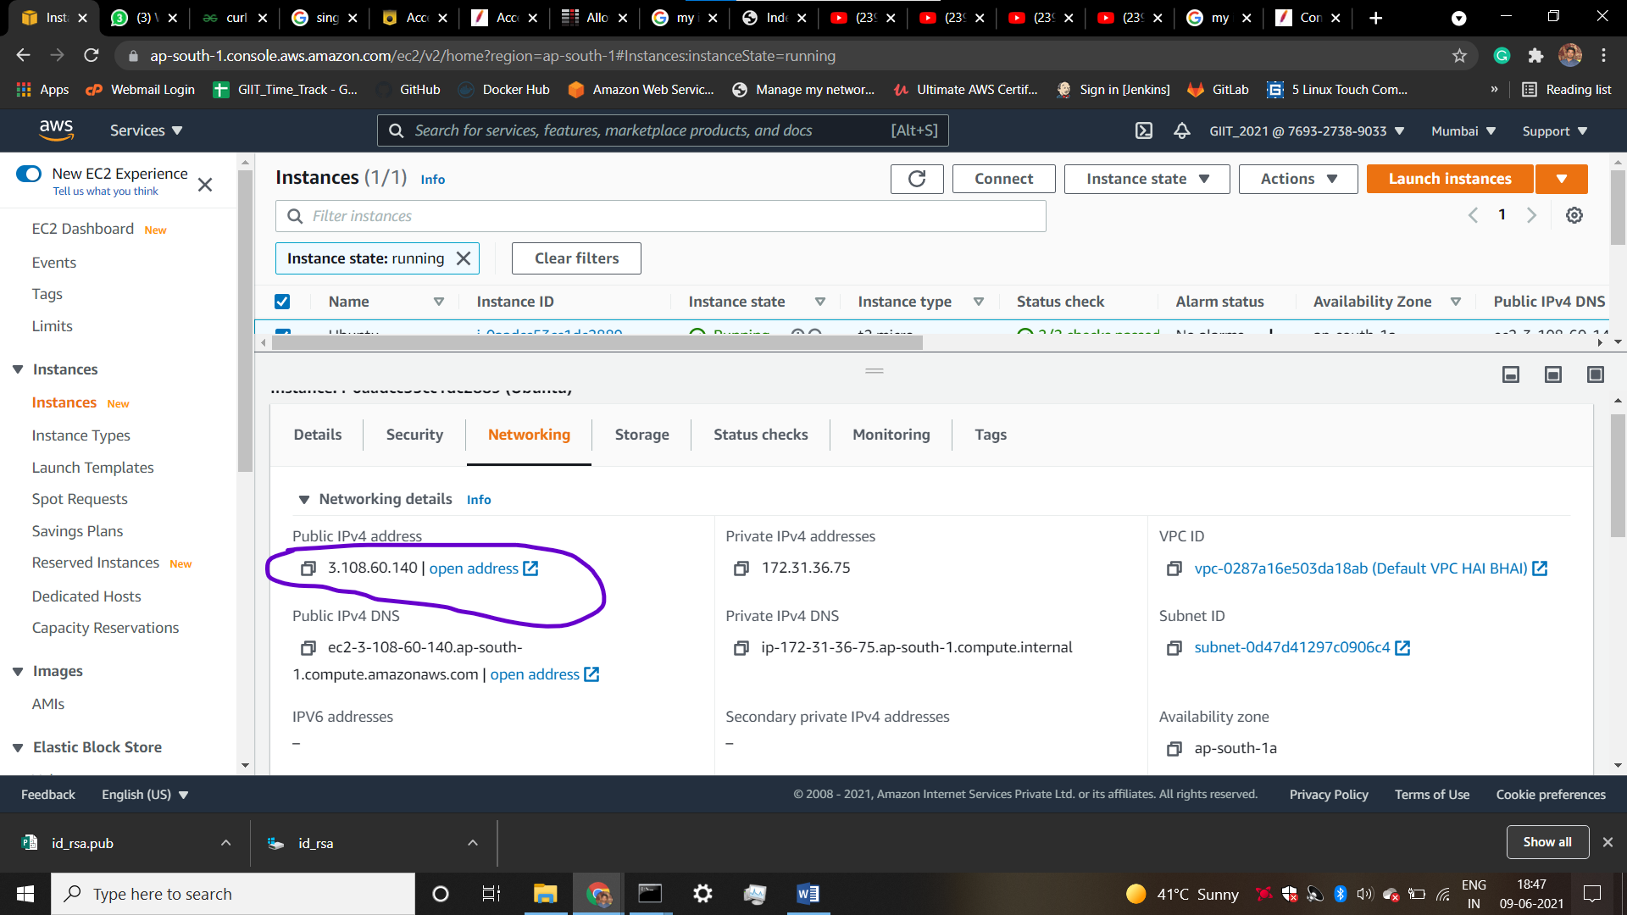

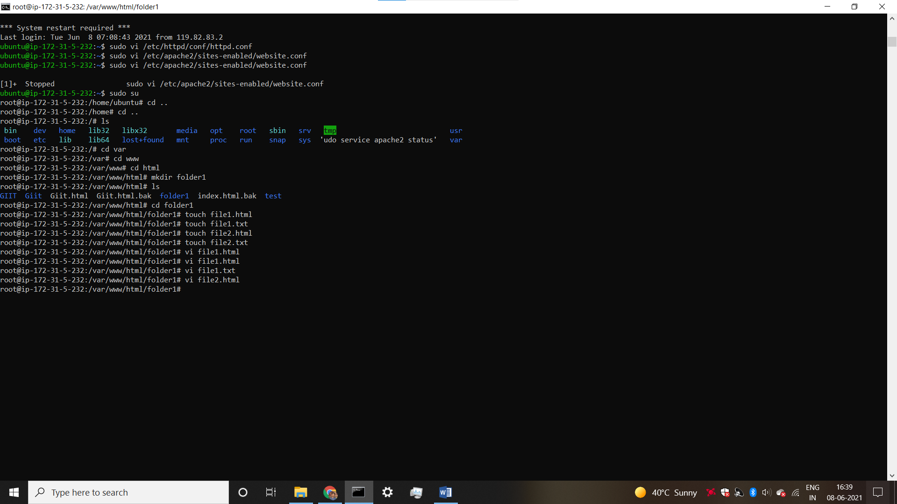

root@ip-172-31-5-232:/# vi /etc/apache2/sites-available/000-default.conf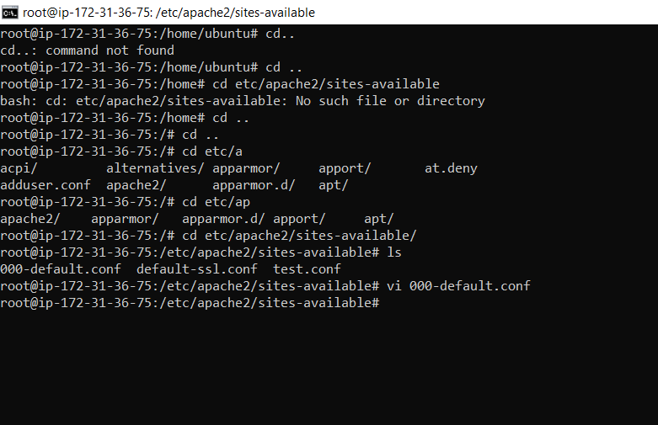

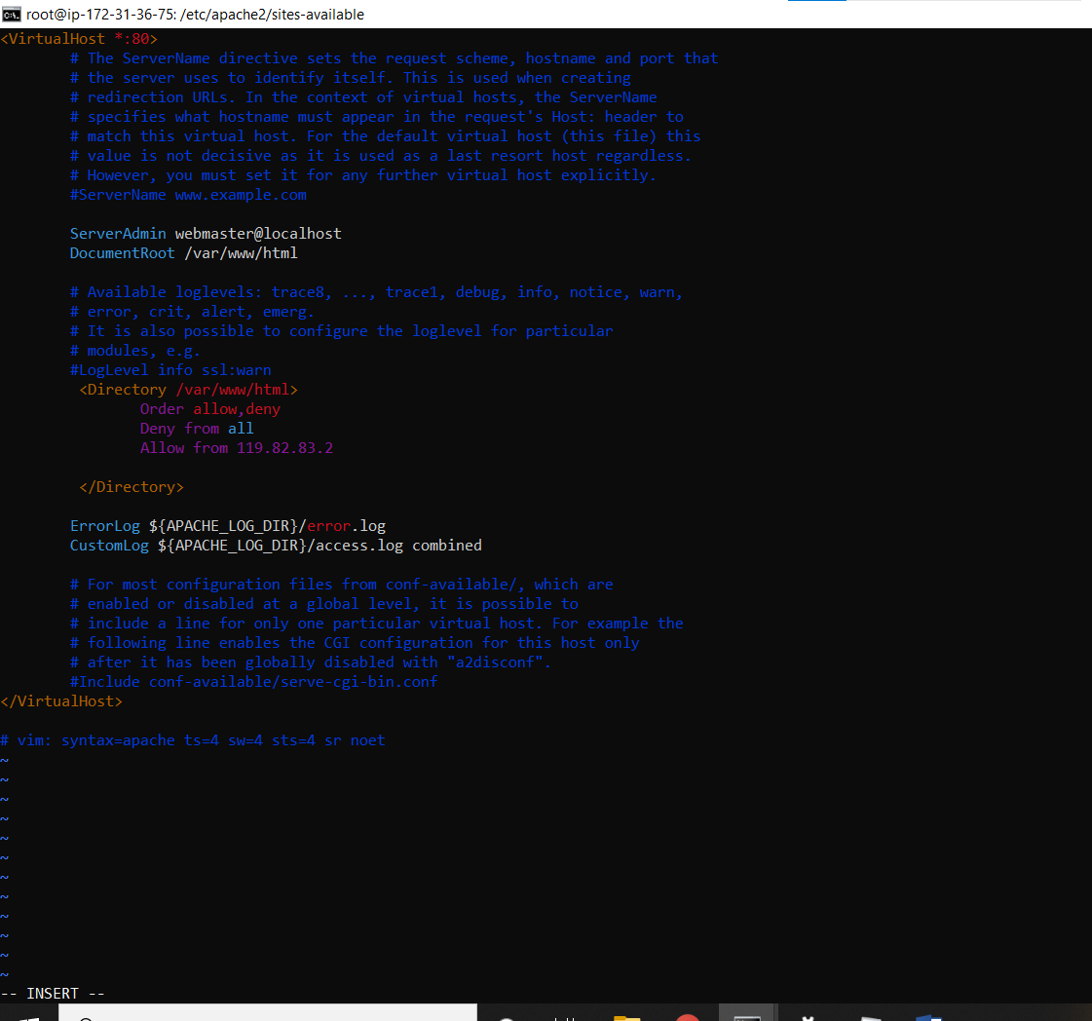

After this restart apache 2 server